Great — this is exactly how top companies test Kubernetes knowledge: scenario-based + hands-on commands. Let’s break this down in a practical, interview-ready way.

✅ 1. Monolithic vs Microservices (Kubernetes Perspective)

🔹 Conceptual Difference
Feature | Monolithic Application | Microservices Application
Architecture | Single codebase | Multiple small services
Deployment | One unit | Independent deployments
Scaling | Scale entire app | Scale individual services
Failure Impact | Whole app affected | Only one service affected
Kubernetes Fit | Not ideal | Perfect fit

🔥 Scenario-Based Explanation (Very Important for Interviews)

🧠 Scenario:
You have an E-commerce Application

🧱 Monolithic App
- One app contains:
  - User Service
  - Order Service
  - Payment Service
👉 If traffic increases → You must scale entire app

🚀 Microservices App
- Separate services:
  - user-service
  - order-service
  - payment-service
👉 You scale only payment-service during heavy transactions

⚙️ How Kubernetes Handles Monolithic vs Microservices

🔴 Monolithic Deployment in Kubernetes

🧪 YAML Example
apiVersion: apps/v1
kind: Deployment
metadata:
name: ecommerce-monolith
spec:
replicas: 3
selector:
matchLabels:
app: ecommerce
template:
metadata:
labels:
app: ecommerce
spec:
containers:
- name: ecommerce-container
image: myrepo/ecommerce:latest
ports:
- containerPort: 8080

🚀 Commands
# Create deployment
kubectl apply -f monolith.yaml

# Check pods
kubectl get pods

# Scale app
kubectl scale deployment ecommerce-monolith --replicas=5

# Expose service
kubectl expose deployment ecommerce-monolith --type=LoadBalancer --port=80 --target-port=8080

❌ Problem (Interview Key Point)
- Even if only payments need scaling, entire app scales
- Resource wastage
- Slower deployments

🟢 Microservices Deployment in Kubernetes

🧪 YAML for Multiple Services

🔹 User Service
apiVersion: apps/v1
kind: Deployment
metadata:
name: user-service
spec:
replicas: 2
selector:
matchLabels:
app: user
template:
metadata:
labels:
app: user
spec:
containers:
- name: user-container
image: myrepo/user:latest
ports:
- containerPort: 8080

🔹 Payment Service
apiVersion: apps/v1
kind: Deployment
metadata:
name: payment-service
spec:
replicas: 2
selector:
matchLabels:
app: payment
template:
metadata:
labels:
app: payment
spec:
containers:
- name: payment-container
image: myrepo/payment:latest
ports:
- containerPort: 8080

🚀 Commands
# Deploy all services
kubectl apply -f user.yaml
kubectl apply -f payment.yaml

# Verify
kubectl get deployments
kubectl get pods

# Expose services
kubectl expose deployment user-service --type=ClusterIP --port=80 --target-port=8080
kubectl expose deployment payment-service --type=ClusterIP --port=80 --target-port=8080

🔥 Scaling Only One Service
# Scale only payment service
kubectl scale deployment payment-service --replicas=5

# Verify scaling
kubectl get pods -l app=payment
👉 This is the biggest advantage of microservices

🔗 Communication Between Microservices
Kubernetes uses Services + DNS
# Inside cluster communication
http://payment-service
http://user-service

🌐 Expose via Ingress (Real-world)
apiVersion: networking.k8s.io/v1
kind: Ingress
metadata:
name: ecommerce-ingress
spec:
rules:
- http:
paths:
- path: /user
pathType: Prefix
backend:
service:
name: user-service
port:
number: 80
- path: /payment
pathType: Prefix
backend:
service:
name: payment-service
port:
number: 80

🚀 Commands
kubectl apply -f ingress.yaml
kubectl get ingress

⚡ Interview Summary Answer (Say This Confidently)
👉 “In Kubernetes, monolithic applications are deployed as a single deployment, so scaling and updates affect the entire application. This leads to inefficient resource usage.
In contrast, microservices are deployed as independent deployments and services. Kubernetes allows us to scale, update, and manage each service independently using Deployments, Services, and Ingress. This makes microservices highly suitable for Kubernetes environments.”

🎯 Bonus: Real-Time Troubleshooting Scenario
👉 Interviewer: Payment service is slow. What will you do?
# Check pods
kubectl get pods -l app=payment

# Check logs
kubectl logs <pod-name>

# Scale service
kubectl scale deployment payment-service --replicas=10

# Check resource usage
kubectl top pods
=======================

Perfect — this is one of the most important Kubernetes interview questions, and interviewers expect architecture + real-time communication flow + commands.
I’ll explain this in a scenario + step-by-step communication flow + commands so you can answer confidently.

✅ 1. Kubernetes Architecture Overview

🧠 High-Level Idea
Kubernetes cluster has:
- Master Node (Control Plane) → Brain 🧠
- Worker Nodes → Execution ⚙️

🧩 Master Node (Control Plane Components)

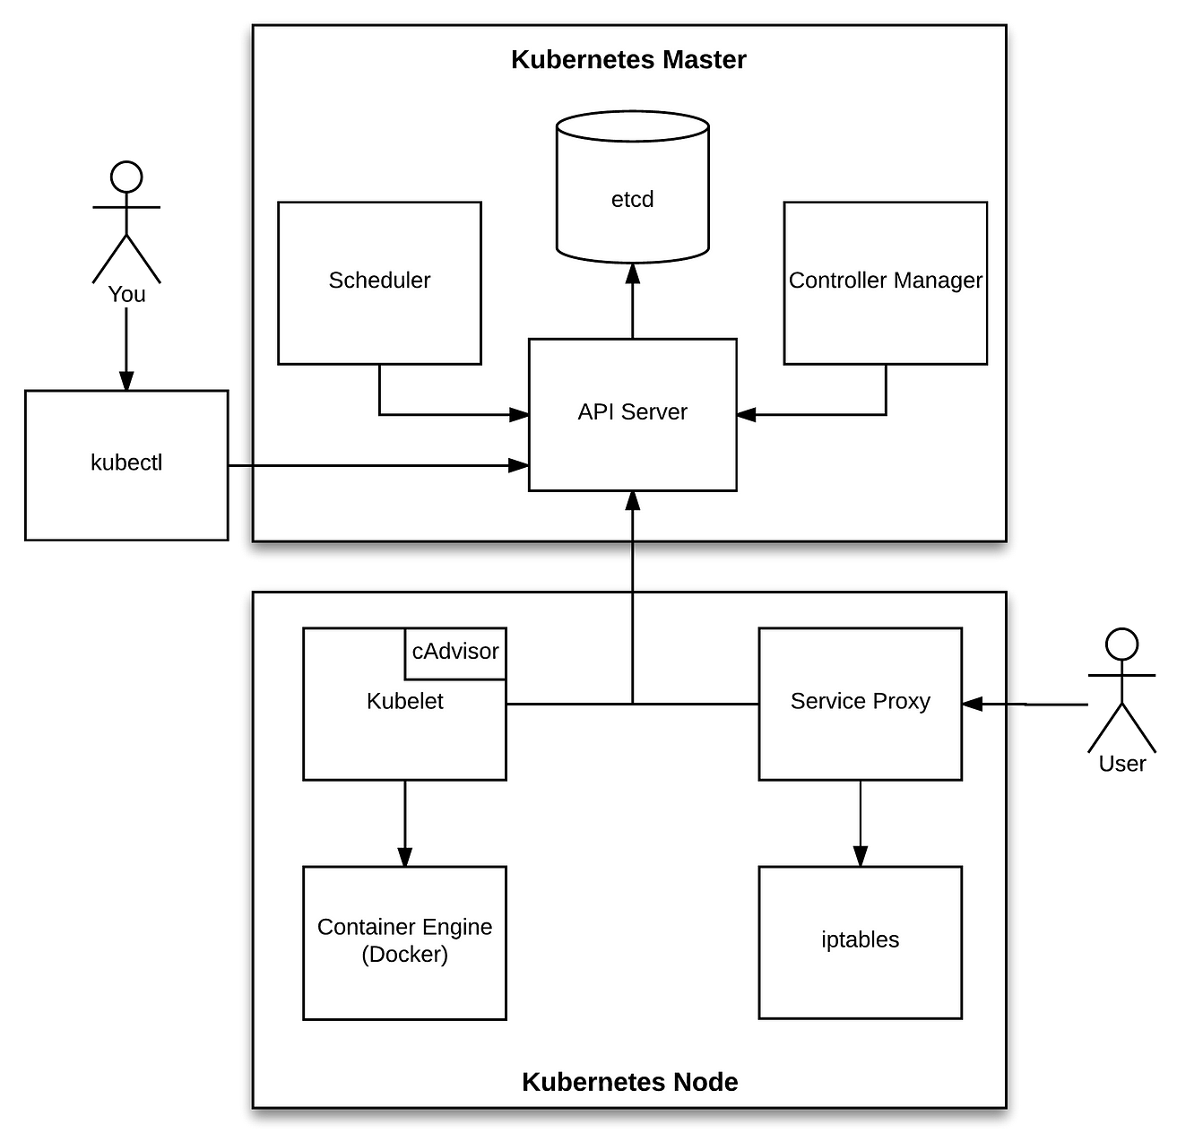

🔹 Components

1. API Server (kube-apiserver)
- Entry point to cluster
- All commands go through this
👉 Example:
kubectl get pods
➡️ Goes to API Server

2. etcd
- Key-value store (cluster database)
- Stores:
  - Pods
  - Deployments
  - Secrets

3. Scheduler (kube-scheduler)
- Decides which node pod should run on
👉 Based on:
- CPU / Memory
- Node labels
- Taints & tolerations

4. Controller Manager
- Maintains desired state
👉 Example:
- You want 3 pods → It ensures always 3 are running

⚙️ Worker Node Components

🔹 Components

1. Kubelet
- Talks to API Server
- Ensures containers are running

2. Kube-Proxy
- Handles networking
- Maintains service routing (iptables)

3. Container Runtime
- Runs containers
👉 Examples:
- containerd
- Docker

🔥 2. End-to-End Kubernetes Communication (INTERVIEW GOLD)

🧠 Scenario:
You run:
kubectl apply -f deployment.yaml

🚀 Step-by-Step Flow

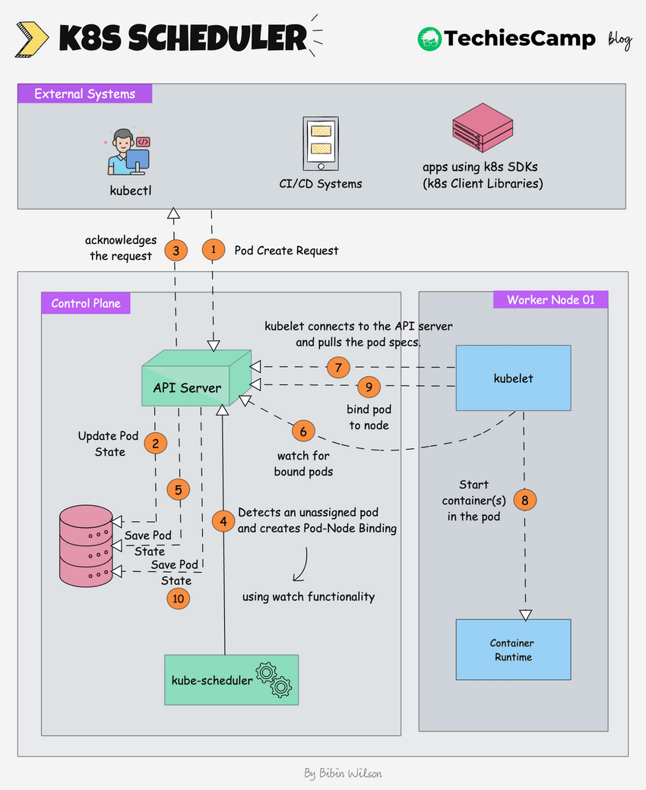

🔹 Step 1: kubectl → API Server
kubectl apply -f deployment.yaml
- Request goes to API Server
- API Server validates request

🔹 Step 2: API Server → etcd
- Deployment is stored in etcd
👉 Desired state recorded

🔹 Step 3: Controller Manager
- Notices new Deployment
- Creates ReplicaSet
- Ensures desired pods count

🔹 Step 4: Scheduler
- Picks best node for pod
👉 Example:
- Node1 has free CPU → Pod assigned there

🔹 Step 5: API Server → Kubelet
- Kubelet on Node1 receives instruction

🔹 Step 6: Kubelet → Container Runtime
- Pulls image
- Starts container
docker pull myapp:latest

🔹 Step 7: Kube-Proxy
- Updates networking rules
- Makes pod accessible via Service

🔹 Step 8: Pod Running ✅
kubectl get pods

🔁 Continuous Monitoring Loop
- Kubelet keeps reporting to API Server
- Controller ensures desired state
👉 If pod crashes:
kubectl delete pod <pod>
➡️ Automatically recreated

⚡ Real-Time Debug Commands (VERY IMPORTANT)

🔍 Check Everything Step-by-Step

1. Check Deployment
kubectl get deployments

2. Check Pods
kubectl get pods -o wide

3. Describe Pod (Key Interview Command)
kubectl describe pod <pod-name>
👉 Shows:
- Node assigned
- Events
- Errors

4. Check Logs
kubectl logs <pod-name>

5. Check Node
kubectl get nodes
kubectl describe node <node-name>

6. Check Events (🔥 Interview Favorite)
kubectl get events

🎯 Interview Answer (Say This Confidently)
👉
“Kubernetes architecture consists of Control Plane and Worker Nodes. The Control Plane includes API Server, etcd, Scheduler, and Controller Manager, which manage cluster state.
When a user submits a request using kubectl, it goes to the API Server, which stores the desired state in etcd. The Controller Manager ensures the required state, and the Scheduler assigns pods to worker nodes. The Kubelet on the worker node pulls the container image and runs it using the container runtime. Kube-proxy manages networking and service routing.”

Perfect — this is exactly how interviewers test real Kubernetes experience:
👉 “Pod is failing — what will you do step by step?”

🚨 1. CrashLoopBackOff

🧠 What it Means
- Container is starting → crashing → restarting repeatedly

🔥 Real Scenario
You deployed a Java app, but:
- DB connection string is wrong
- App crashes immediately

🔍 How to Identify
kubectl get pods
Output:
myapp-xyz 0/1 CrashLoopBackOff

⚙️ Troubleshooting Steps

1. Check Logs (MOST IMPORTANT)
kubectl logs <pod-name>
👉 Look for:
- NullPointerException
- DB connection error
- Port already in use

2. Check Previous Logs (🔥 Important)
kubectl logs <pod-name> --previous
👉 Shows crash before restart

3. Describe Pod
kubectl describe pod <pod-name>
👉 Look at:
- Events
- Exit code
- Restart count

4. Check Restart Count
kubectl get pod <pod-name> -o wide

🛠️ Common Causes + Fix
Cause | Fix
Wrong ENV variables | Update ConfigMap/Secrets
App crash | Fix code / config
Port conflict | Change containerPort
Missing dependency | Fix image

🧯 Fix Example
kubectl edit deployment myapp
Update ENV:
env:
- name: DB_HOST
value: correct-db-url
Then:
kubectl rollout restart deployment myapp

🚨 2. ImagePullBackOff / ErrImagePull

🧠 What it Means
- Kubernetes cannot pull container image

🔥 Real Scenario
- Image name wrong
- Private repo without credentials
- Tag doesn’t exist

🔍 Identify
kubectl get pods
Output:
ErrImagePull / ImagePullBackOff

⚙️ Troubleshooting Steps

1. Describe Pod (🔥 MAIN COMMAND)
kubectl describe pod <pod-name>
👉 Look at:
Failed to pull image "myapp:v2": image not found

2. Check Image Name
kubectl get pod <pod-name> -o yaml | grep image

3. Check Docker Registry Access
docker pull myrepo/myapp:v1

🛠️ Common Causes + Fix
Cause | Fix
Wrong image name | Correct image
Wrong tag | Use valid tag
Private repo | Add imagePullSecrets
Network issue | Check node connectivity

🧯 Fix Example

🔹 Add Secret for Private Registry
kubectl create secret docker-registry my-secret \
--docker-username=user \
--docker-password=pass \
--docker-email=email@example.com

🔹 Attach Secret
imagePullSecrets:
- name: my-secret

🔹 Restart Deployment
kubectl rollout restart deployment myapp

🚨 3. Pods Frequently Restarting

🧠 What it Means
- Pod is running but restarting often

🔥 Real Scenario
- Liveness probe failing
- App slow to start
- Memory issues

🔍 Identify
kubectl get pods
Check:
RESTARTS: 10+

⚙️ Troubleshooting Steps

1. Describe Pod
kubectl describe pod <pod-name>
👉 Look for:
Liveness probe failed

2. Check Logs
kubectl logs <pod-name>

3. Check Resource Usage
kubectl top pods

4. Check Probes
kubectl get pod <pod-name> -o yaml

🛠️ Common Causes + Fix
Cause | Fix
Liveness probe too strict | Increase delay
App slow startup | Add readiness probe
Memory limit low | Increase resources
CPU throttling | Increase CPU

🧯 Fix Example

🔹 Fix Liveness Probe
livenessProbe:
httpGet:
path: /health
port: 8080
initialDelaySeconds: 30
periodSeconds: 10

🔹 Update Resources
resources:
requests:
memory: "256Mi"
limits:
memory: "512Mi"

🔹 Apply Changes
kubectl apply -f deployment.yaml

🔥 End-to-End Debug Flow (INTERVIEW GOLD)
👉 If pod is failing, ALWAYS follow this order:
# 1. Check pod status
kubectl get pods

# 2. Describe pod (MOST IMPORTANT)
kubectl describe pod <pod-name>

# 3. Check logs
kubectl logs <pod-name>

# 4. Check previous logs
kubectl logs <pod-name> --previous

# 5. Check events
kubectl get events

# 6. Check node
kubectl describe node <node-name>

🎯 Final Interview Answer (Say This)
👉
“When troubleshooting Kubernetes issues like CrashLoopBackOff or ImagePullBackOff, I first check pod status using kubectl get pods, then use kubectl describe pod to see events and errors. I analyze logs using kubectl logs and --previous for crash history. Based on the issue, I fix configuration, image, or resource limits and then restart the deployment.”

🎯 1. How to Restrict Memory Utilization of Pods

🧠 Concept (VERY IMPORTANT)
Kubernetes uses:
- Requests → Minimum guaranteed memory
- Limits → Maximum allowed memory
👉 If container crosses limit → OOMKilled (pod restarts)

🔥 Scenario
Your pod is:
- Using too much memory
- Affecting other pods on same node
👉 You want to control it

🧪 YAML Example
apiVersion: apps/v1
kind: Deployment
metadata:
name: myapp
spec:
replicas: 2
template:
spec:
containers:
- name: myapp-container
image: myapp:latest
resources:
requests:
memory: "256Mi"
cpu: "200m"
limits:
memory: "512Mi"
cpu: "500m"

🚀 Apply Configuration
kubectl apply -f deployment.yaml

🔍 Verify
kubectl describe pod <pod-name>
👉 Look for:
Limits: memory: 512Mi
Requests: memory: 256Mi

📊 Monitor Usage
kubectl top pods

⚠️ Interview Tip
👉
“If memory exceeds limit → Kubernetes kills container (OOMKilled) and restarts it.”

🔥 2. How to Reduce Pod Size (Real Meaning)
This has 2 dimensions:

✅ A. Reduce Container Image Size

🧠 Scenario
Your image is:
- 1GB (very large)
- Slow to pull → pods start slowly

🛠️ Fix

🔹 Use Lightweight Base Image
❌ Bad:
FROM ubuntu
✅ Good:
FROM alpine

🔹 Multi-Stage Build (🔥 Interview Favorite)
# Build stage
FROM maven:3.8 AS build
COPY . .
RUN mvn clean package

# Runtime stage
FROM openjdk:17-jdk-slim
COPY --from=build target/app.jar app.jar
CMD ["java", "-jar", "app.jar"]
👉 Removes unnecessary build tools → smaller image

🔹 Remove Unnecessary Files
RUN apt-get clean && rm -rf /var/lib/apt/lists/*

🚀 Build & Push
docker build -t myapp:optimized .
docker push myapp:optimized

🔁 Update Deployment
kubectl set image deployment/myapp myapp-container=myapp:optimized

✅ B. Reduce Resource Consumption (Pod Optimization)

🧠 Scenario
Pod is:
- Over-consuming CPU/memory
- Node is getting exhausted

🛠️ Fix with Limits
resources:
requests:
memory: "128Mi"
cpu: "100m"
limits:
memory: "256Mi"
cpu: "300m"

🚀 Update Deployment
kubectl edit deployment myapp
OR
kubectl apply -f deployment.yaml

🚨 3. Enforce Limits for Entire Namespace (VERY IMPORTANT)
👉 Prevent developers from deploying unlimited pods

🔒 Use LimitRange
apiVersion: v1
kind: LimitRange
metadata:
name: mem-limit
spec:
limits:
- default:
memory: "512Mi"
defaultRequest:
memory: "256Mi"
type: Container

🚀 Apply
kubectl apply -f limitrange.yaml

🔥 Use ResourceQuota (Cluster-Level Control)
apiVersion: v1
kind: ResourceQuota
metadata:
name: mem-quota
spec:
hard:
requests.memory: "1Gi"
limits.memory: "2Gi"

🚀 Apply
kubectl apply -f quota.yaml

🔍 Troubleshooting High Memory Usage

Step 1: Check Usage
kubectl top pods

Step 2: Describe Pod
kubectl describe pod <pod-name>
👉 Look for:
OOMKilled

Step 3: Check Logs
kubectl logs <pod-name>

⚡ Real Interview Scenario
👉 Interviewer: Pod is getting OOMKilled — what will you do?

✅ Answer Flow:
kubectl describe pod <pod-name>
Check:
- Memory limits
- OOMKilled event

Fix:
resources:
limits:
memory: "1Gi"

Then:
kubectl rollout restart deployment myapp

🎯 Final Interview Answer
👉
“To reduce pod size, I optimize container images using lightweight base images like Alpine and multi-stage builds. To restrict memory usage, I define resource requests and limits in the deployment YAML. Additionally, I use LimitRange and ResourceQuota to enforce constraints at namespace level and monitor usage using kubectl top pods.”

Difference Between ENTRYPOINT vs CMD

🧠 Core Idea
Feature | ENTRYPOINT | CMD
Purpose | Defines main executable | Default arguments
Overridable | Hard to override | Easy to override
Behavior | Always runs | Can be replaced
Use Case | Fixed app | Flexible parameters

🔥 Simple Analogy (Interview Gold)
👉 Think of it like:
- ENTRYPOINT = Application (java, python, nginx)
- CMD = Arguments (file name, options)

🧪 Docker Example

✅ Using ENTRYPOINT + CMD Together
FROM openjdk:17
COPY app.jar app.jar
ENTRYPOINT ["java", "-jar"]
CMD ["app.jar"]

🎯 Final Interview Answer (Perfect)
👉
“ENTRYPOINT defines the main executable of a container, while CMD provides default arguments. In Kubernetes, ENTRYPOINT maps to the command field and CMD maps to args. ENTRYPOINT is generally used for fixed execution, whereas CMD allows flexibility and can be overridden at runtime.”

🎯 What is Multi-Stage Docker Build? Diff bw Bluegreen, Canary and roling
👉 A multi-stage Dockerfile uses multiple FROM statements to:
- Build the application in one stage
- Run it in another stage
- Discard unnecessary files (like build tools, source code, dependencies)

🧪 Example (Java App)
# 🔹 Stage 1: Build Stage
FROM maven:3.8 AS build
WORKDIR /app
COPY . .
RUN mvn clean package
# 🔹 Stage 2: Runtime Stage
FROM openjdk:17-jdk-slim
WORKDIR /app
COPY --from=build /app/target/app.jar app.jar
CMD ["java", "-jar", "app.jar"]

🔥 What Happens Step-by-Step (VERY IMPORTANT)

🧩 Step 1: Build Stage Executes
FROM maven:3.8 AS build
👉 Docker creates a temporary container
Then:
mvn clean package
👉 Produces:
/app/target/app.jar

🧩 Step 2: Runtime Stage Starts
FROM openjdk:17-jdk-slim
👉 A new clean image is created

🧩 Step 3: Copy Only Required File
COPY --from=build /app/target/app.jar app.jar
👉 Only the final artifact is copied

🧩 Step 4: Final Image Created
👉 Final image contains:
- ✅ app.jar
- ✅ Java runtime
- ❌ No Maven
- ❌ No source code
- ❌ No build cache

🚨 Key Answer: What Happens After Build?
👉 After build completes:
- Only the last stage image is kept
- All previous stages are discarded (not included in final image)
- Intermediate layers are used only during build time

Difference Between Blue-Green, Canary, and Rolling Deployment
These are deployment strategies used in DevOps to release new application versions with minimal downtime and risk.

Simple Overview
Strategy | Traffic Shift | Downtime | Risk | Rollback
Rolling | Gradual server replacement | No | Medium | Moderate
Blue-Green | Switch entire environment | Near Zero | Low | Very Easy
Canary | Small % users first | No | Lowest | Easy

1. Rolling Deployment
Application updates happen gradually server by server.

Example
Suppose you have:
4 application servers
Terraform/Kubernetes/Jenkins updates:
Server 1 -> New Version
Server 2 -> New Version
Server 3 -> New Version
Server 4 -> New Version
one at a time.

Flow
Old Old Old Old

↓

New Old Old Old

↓

New New Old Old

↓

New New New Old

↓

New New New New

Advantages
✅ No downtime
✅ Simple
✅ Less infrastructure cost

Disadvantages
❌ Old + new versions run together temporarily
❌ Rollback slower
❌ Possible version mismatch issues

Real-Time Use
Common in:
- Kubernetes
- VM Scale Sets
- Application servers

2. Blue-Green Deployment
Two identical environments exist.
Environment | Version
Blue | Old Version
Green | New Version
Traffic switches completely after testing.

Flow
Users ---> BLUE (Old App)

Deploy new app to GREEN

Test GREEN

Switch Traffic

Users ---> GREEN (New App)

Important
Blue stays untouched during deployment.
Rollback is instant.

Advantages
✅ Near zero downtime
✅ Instant rollback
✅ Safe deployments

Disadvantages
❌ Double infrastructure cost
❌ Need duplicate environments

Real-Time Example
Azure:
- App Service Deployment Slots
- AKS namespaces
- Load Balancer switch
AWS:
- Elastic Beanstalk
- ECS
- ALB switching

3. Canary Deployment
New version released to SMALL percentage of users first.

Flow
95% Users -> Old Version
5% Users -> New Version
Monitor:
- errors
- crashes
- CPU
- logs
- customer feedback
If stable:
50% -> New
100% -> New

Real-Time Example
YouTube
Instagram
Netflix
Amazon
They test features on limited users first.

Advantages
✅ Lowest risk
✅ Real-user testing
✅ Gradual rollout
✅ Safer production deployments

Disadvantages
❌ More complex
❌ Requires traffic management
❌ Monitoring mandatory

Real-Time Tools
Tool | Usage
Kubernetes | Canary deployments
Istio | Traffic splitting
NGINX Ingress | Canary routing
Argo Rollouts | Advanced deployments
Azure Front Door | Traffic shifting

Easiest Way to Remember

Rolling
Replace servers gradually

Blue-Green
Switch entire environment

Canary
Test on few users first

Visual Comparison

Rolling
Old Old Old Old
↓
New Old Old Old
↓
New New Old Old

Blue-Green
BLUE -> Old
GREEN -> New

Switch Traffic

Canary
95% -> Old
5% -> New

Real-Time Industry Preference
Scenario | Best Strategy
Simple infra | Rolling
Critical production | Blue-Green
Large-scale SaaS | Canary

Interview Answer
Rolling deployment updates application instances gradually one by one. Blue-Green deployment maintains two identical environments and switches traffic entirely to the new environment after validation. Canary deployment releases the new version to a small subset of users first, monitors stability, and gradually increases traffic. Canary offers the lowest deployment risk, while Blue-Green provides fastest rollback capability.

Pod Error | Meaning | How to Identify | Troubleshooting
CrashLoopBackOff | Container starts and crashes repeatedly | kubectl get pods shows CrashLoopBackOff | Check application logs using kubectl logs, validate env variables, startup command, DB/API connectivity
ImagePullBackOff | Kubernetes unable to pull image | kubectl describe pod <pod> → Events section | Verify image name/tag, registry access, imagePullSecrets, image availability
ErrImagePull | Initial image pull failed | kubectl get pods shows ErrImagePull | Check image spelling, tag existence, registry authentication, network access
Pending | Pod waiting for scheduling/resources | kubectl describe pod <pod> → Events | Check node resources, PVC binding, taints/tolerations, scheduler constraints
OOMKilled | Container exceeded memory limit | kubectl describe pod <pod> shows OOMKilled | Increase memory limits, optimize app memory usage, check memory leaks
CreateContainerConfigError | Configuration issue before container creation | kubectl describe pod <pod> → Events | Validate ConfigMaps, Secrets, env variables, volume mounts
CreateContainerError | Container runtime failed to create container | kubectl describe pod <pod> | Check command syntax, mounted paths, permissions, runtime configuration
ContainerCreating | Pod is still initializing | kubectl get pods shows ContainerCreating | Check image pulling, storage mounts, CNI/network plugin, node health
RunContainerError | Container failed during runtime start | kubectl describe pod <pod> | Validate entrypoint command, dependencies, permissions, startup scripts
Completed | Container finished successfully | kubectl get pods shows Completed | Normal for Jobs/CronJobs, verify restart policy and logs if unexpected

Most Common Troubleshooting Commands
Command | Purpose
kubectl get pods | View pod status
kubectl describe pod <pod> | Detailed pod events and errors
kubectl logs <pod> | View container logs
kubectl logs <pod> --previous | View previous crashed container logs
kubectl get events | Cluster events and scheduling issues
kubectl get nodes | Node health and availability

